# CS 255 System Design Document Template

*Brandon Randall*

*6/16/23*

*CS255*

## UML Diagrams

### UML Use Case Diagram

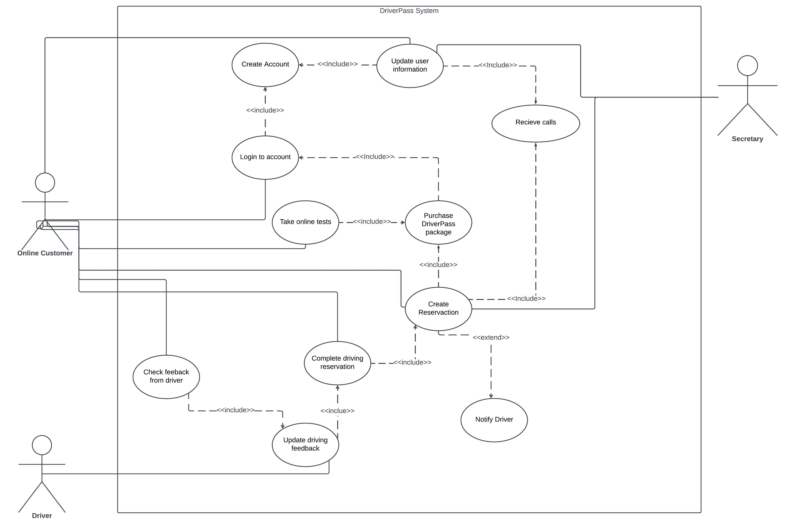

### UML Activity Diagrams

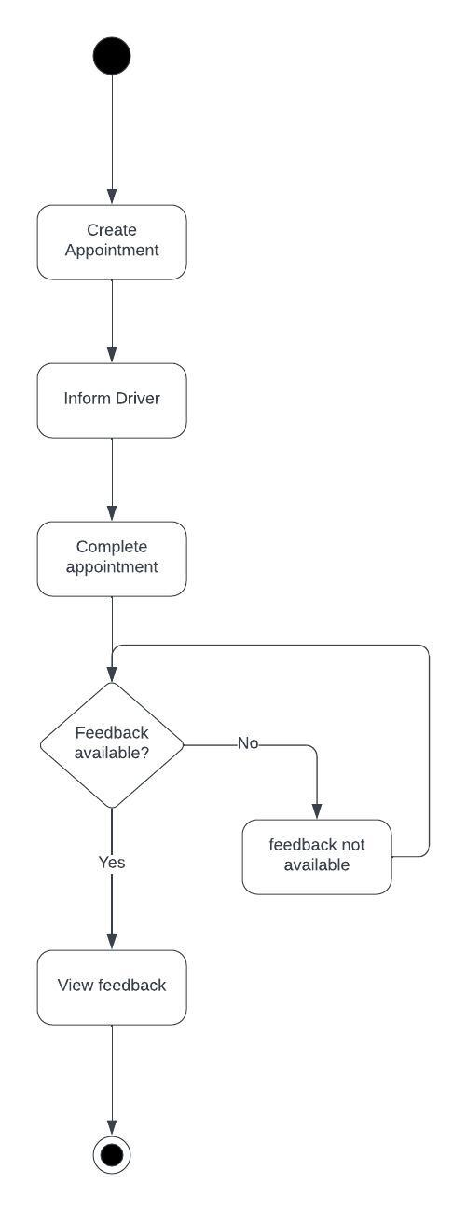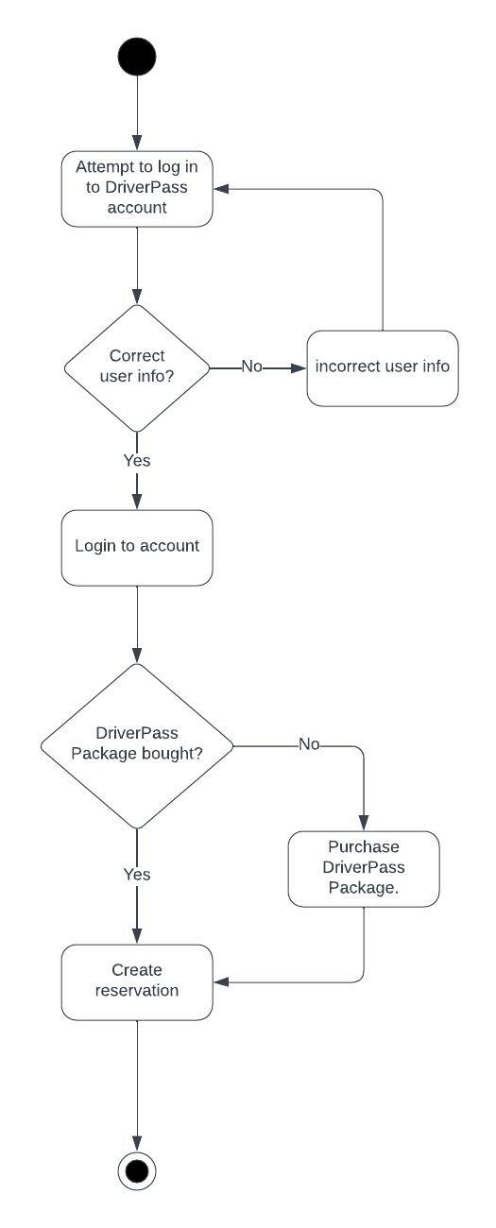

### UML Sequence Diagram

*Use case: check feedback from driver*

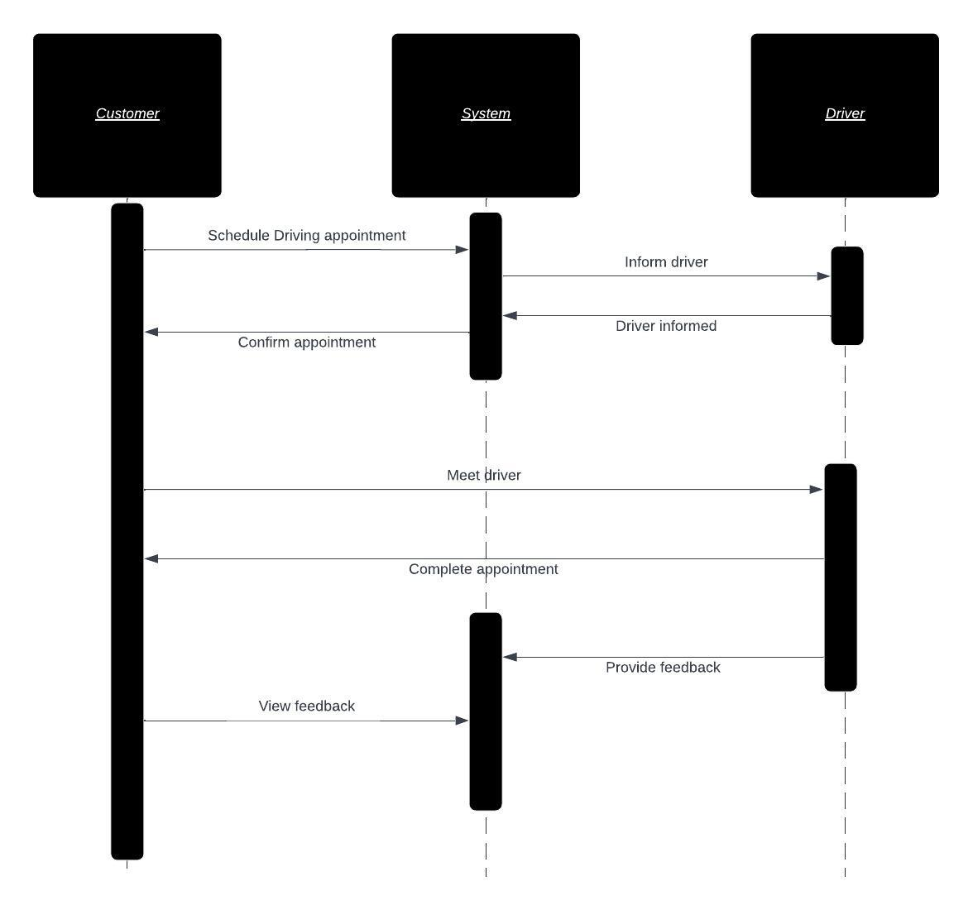

### UML Class Diagram

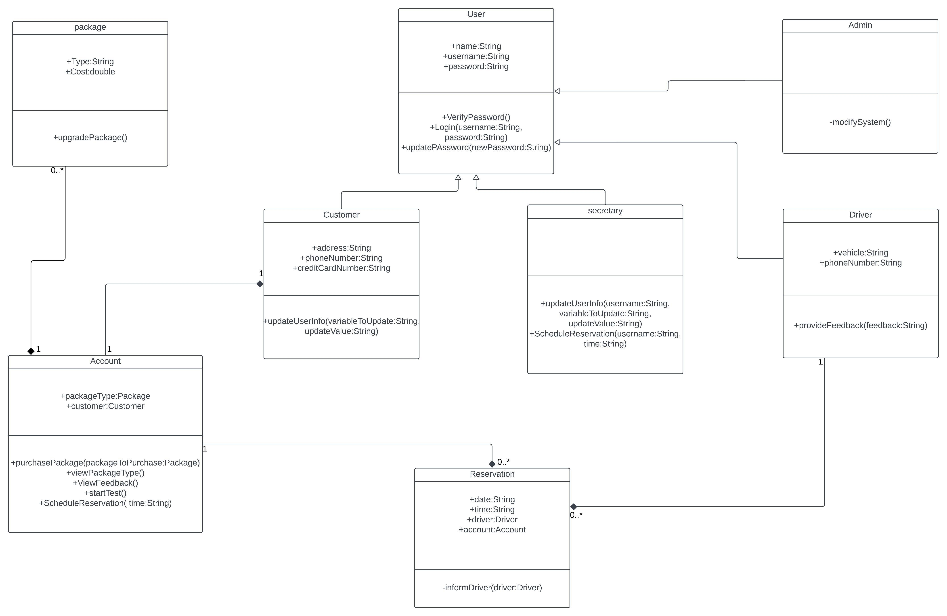

## Technical Requirements

*Hardware*

* *With this site being cloud based, there is no physical server hardware required, but the office should have modern equipment available to view, interact with, and manage the site, such as desktops/laptops running windows.*
* *The cloud provider should be reliable ensuring the site is consistently up.*
* *An internet connection is necessary within the office to manage and update the system.*

*Software*

* *A database is necessary to store user information, reservation schedules, drivers, vehicles, etc.*
* *Security features are necessary, especially with the site storing information such as addresses and credit card information.*
* *System backups are necessary to ensure that in the case of a system error there’s a relatively recent point to restart from.*

*Additional*

* *System must comply with up-to-date DMV policies.*
* *The system should have a set distance for reservation addresses to ensure drivers do not have to drive long distances to meet users.*